Creating Git and Adding documents to the Git-hub repository

Step 1. open browser enter github.

create github account ->username password
Login using username & password
Create repository

Step 2. open Git Bash.

Go to your folder



Initialize Git (only if this folder is not already a Git repository)



Check the status



Add only the required document

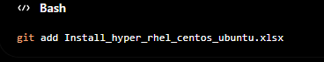

Verify it was staged

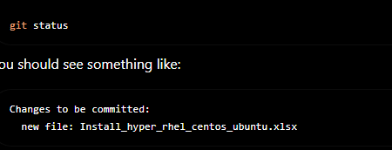

Commit the file

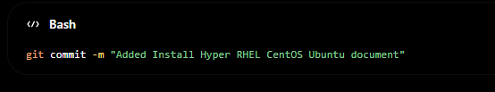

Connect to your GitHub repository (only once)

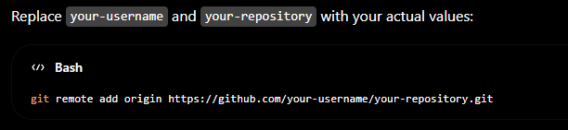

Push the document



You can add all documents in one time instead of individual adding use this commands

